＜How to Use Web Syllabus＞

Access Acanthus Portal using a PC on campus.

アカンサスポータル
https://acanthus.cis.kanazawa-u.ac.jp/

Select the Language （JP/EN） and click "LOGIN".
Enter your Kanazawa University ID and temporary password and click LOGIN.

①：Click “Student Information Service” on the top page.

⇒Course grades
⇒Syllabi

②Fill in the forms and click “Search.”

←Select the year of the courses.
←Select the faculty. e.g.) School of International Education
←Select the quarter of the courses. (Ｑ3, Q4)

Q

←Fill in the forms.

←Click HERE.

③Search results are displayed. Click “Eng(English)”.
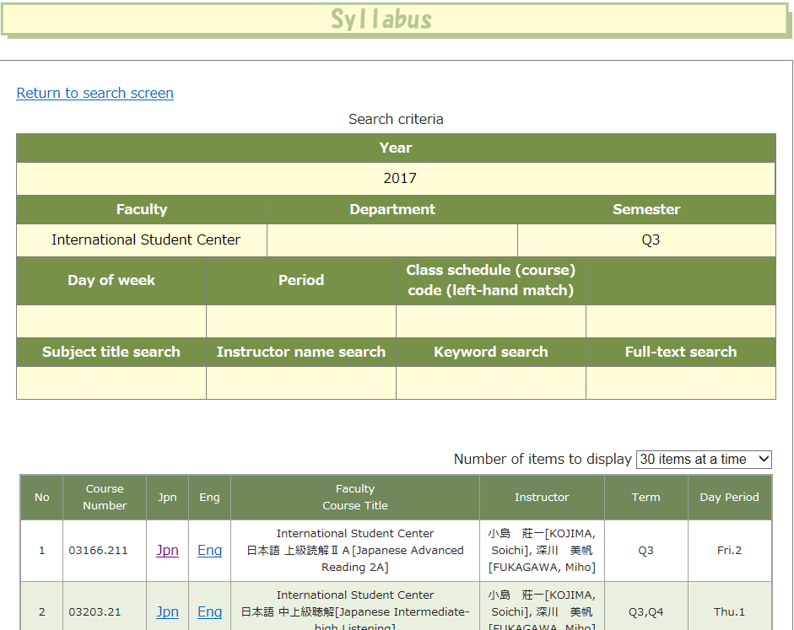

↓Click HERE.

④The syllabus of the course is displayed.
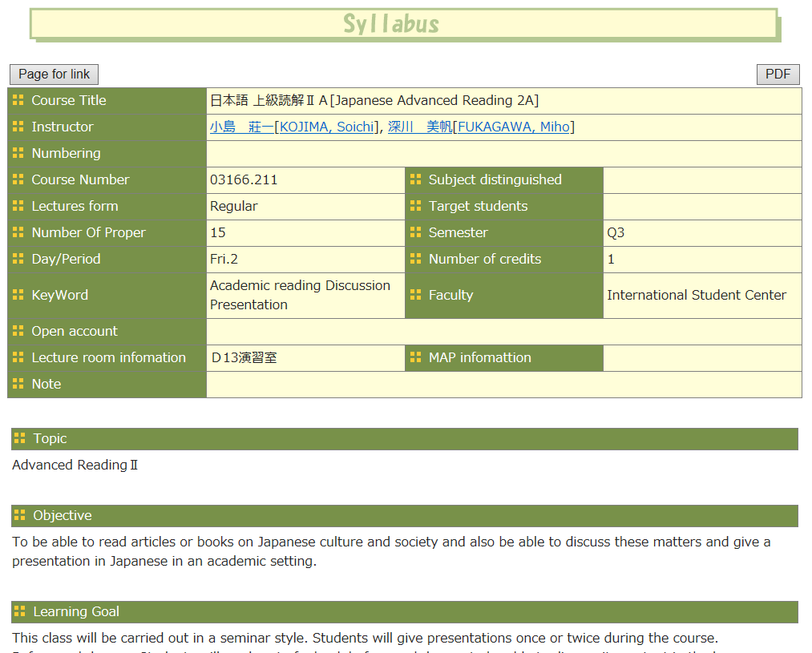

＜How to Register Courses＞

Access Acanthus Portal using a PC on campus.

アカンサスポータル
https://acanthus.cis.kanazawa-u.ac.jp/

Select the Language （JP/EN） and click "LOGIN".
Enter your Kanazawa University ID and temporary password and click LOGIN.

①：Click “Student Information Service” on the top page.

①

⇒Course grades
⇒Course Regist

②：Choose the subject sort name “School of International Education.”
②-1：Default is "Enter a class schedule format."
②-2：Click "Add" on the period of the timetable you want to take.
②

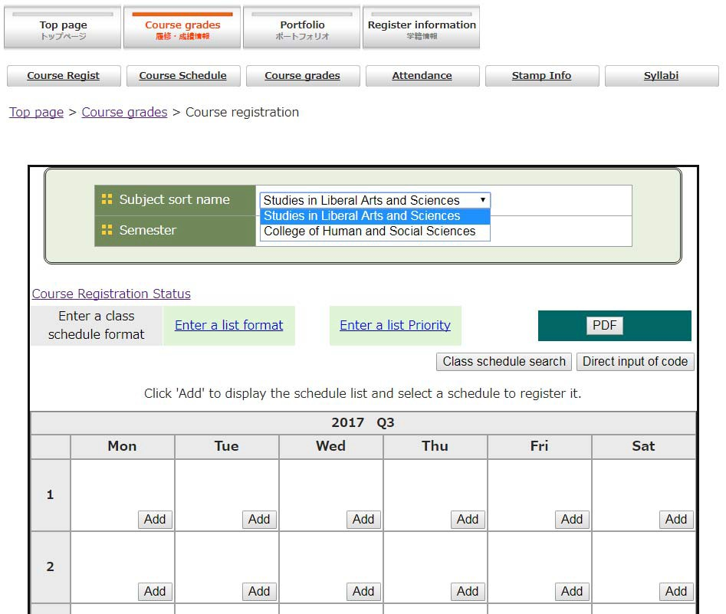

②-1
②-1

②-2
②-2

③："Add" the subject you want to register.
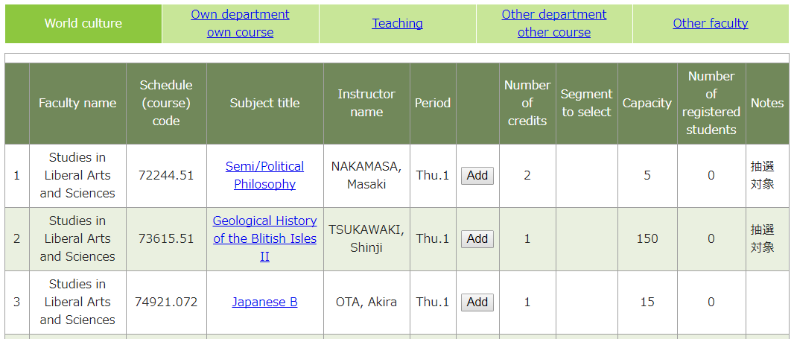
③
③

